Data : C:\Users\Lenovo\AppData\Local\Temp\~vsB631.sql

Video link: https://www.youtube.com/watch?v=sCsXMDD0vls

Customers details:

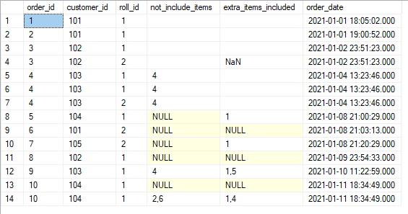

Drivers orders details:

Ingredient details:

Drivers details: Rolls details: rolls ingredients:

Solutions:

A. roll matrics:

1. how many rolls was ordered?

select count(roll_id) as roll_count from customer_orders



2. how many unique customer orders were made?

select count(distinct customer_id) as unique_customers from customer_orders



3. success full orders delivered by drivers?

select * from driver_order

select driver_id,count(distinct order_id) as succesfuly_delevered from driver_order

where cancellation not in ('cancellation','Customer Cancellation')

group by driver_id

4. how many rolls delivered( veg and nonveg)?

Step 1: get all the succesful delevery data

Since here only 2 unsuccesful delivery so we need to remove it but if we use “where cancellation not in ('cancellation','Customer Cancellation')” it will remove null and blank also so we will use case.

select * , case when cancellation in ('cancellation','Customer Cancellation')

then 'c' else 'nc' end as order_cancel_details from driver_order

Details of succesful delivery:

select a.* from (select * , case when cancellation in ('cancellation','Customer Cancellation')

then 'c' else 'nc' end as order_cancel_details from driver_order)a where order_cancel_details = 'nc'

Step 2: get the roll information that is which customer order veg and nonveg rolls

succesfull customer orders:

select * from customer_orders where order_id in

(select order_id from (select * , case when cancellation in ('cancellation','Customer Cancellation')

then 'c' else 'nc' end as order_cancel_details from driver_order)a where order_cancel_details = 'nc')

Final solution: So no of type of rolls sold

select roll_id,count(roll_id) Total_count from customer_orders where order_id in

(select order_id from (select * , case when cancellation in ('cancellation','Customer Cancellation')

then 'c' else 'nc' end as order_cancel_details from driver_order)a where order_cancel_details = 'nc')

group by roll_id

5. how many veg and nonveg rolls were ordered by each cutomer?

Step 1: get the total rolls order by customers

select customer_id,roll_id,count(roll_id) rollid_counts from customer_orders

group by customer_id,roll_id

Step 2: inner join rolls table

select a.*, b.roll_name from

(select customer_id,roll_id,count(roll_id) rollid_counts from customer_orders

group by customer_id,roll_id)a inner join rolls b on a.roll_id = b.roll_id

6. what was the maximum no of rolls delivered in a single order?

Step: 1 remove all the cancelled order( code taken form question 4 step 1)

select order_id from (select * , case when cancellation in ('cancellation','Customer Cancellation')

then 'c' else 'nc' end as order_cancel_details from driver_order)a where order_cancel_details = 'nc'

Step 2: details of all succesful delivery

select * from customer_orders where order_id in (select order_id from (select * , case when cancellation in ('cancellation','Customer Cancellation')

then 'c' else 'nc' end as order_cancel_details from driver_order)a where order_cancel_details = 'nc')

Step 3:

select order_id,count(roll_id) as rolls_count from (select * from customer_orders where order_id in

(select order_id from (select * , case when cancellation in ('cancellation','Customer Cancellation')

then 'c' else 'nc' end as order_cancel_details from driver_order)a where order_cancel_details = 'nc'))b

group by order_id

Step 4: find the max rolls count

select * ,rank() over(order by rolls_count desc) rnk from (select order_id,count(roll_id) as rolls_count from (select * from customer_orders where order_id in

(select order_id from (select * , case when cancellation in ('cancellation','Customer Cancellation')

then 'c' else 'nc' end as order_cancel_details from driver_order)a where order_cancel_details = 'nc'))b

group by order_id)c

Final solution:

select * from

(select * ,rank() over(order by rolls_count desc) rnk from (select order_id,count(roll_id) as rolls_count from (select * from customer_orders where order_id in

(select order_id from (select * , case when cancellation in ('cancellation','Customer Cancellation')

then 'c' else 'nc' end as order_cancel_details from driver_order)a where order_cancel_details = 'nc'))b

group by order_id)c)d where rnk =1



7. for each customer, how many delivered rolls had at least 1 change and how many had no changes?

Step 1: clean the data ( remove null and vacant spaces)

Creating temporary table:

with temp_customer_orders (order_id,customer_id,roll_id,not_include_items,extra_items_included,order_date) as

(

select order_id,customer_id,roll_id, case when not_include_items is null or not_include_items=' ' then '0' else not_include_items

end as new_not_include_items,

case when extra_items_included is null or extra_items_included='NaN' or extra_items_included=' ' then '0' else extra_items_included

end as new_extra_items_included, order_date from customer_orders

)

select * from temp_customer_orders

Now removing the cancellation and noncancellation from drivers orders:

with temp_driver_order(order_id,driver_id,pickup_time,distance,duration,new_cancellation) as

(

select order_id,driver_id,pickup_time,distance,duration,

case when cancellation in ('cancellation','Customer Cancellation') then 0 else 1 end as new_cancellation

from driver_order

)

select * from temp_driver_order

Now remove cancelled:

select * from temp_driver_order where new_cancellation !=0

Final solution: join tempory customer and deliver

with temp_customer_orders (order_id,customer_id,roll_id,not_include_items,extra_items_included,order_date) as

(

select order_id,customer_id,roll_id, case when not_include_items is null or not_include_items=' ' then '0' else not_include_items

end as new_not_include_items,

case when extra_items_included is null or extra_items_included='NaN' or extra_items_included=' ' then '0' else extra_items_included

end as new_extra_items_included, order_date from customer_orders

)

, temp_driver_order(order_id,driver_id,pickup_time,distance,duration,new_cancellation) as

(

select order_id,driver_id,pickup_time,distance,duration,

case when cancellation in ('cancellation','Customer Cancellation') then 0 else 1 end as new_cancellation

from driver_order

)

select * from temp_customer_orders where order_id in (

select order_id from temp_driver_order where new_cancellation !=0)

Now checking for changes in order i.e any item included or removed:

with temp_customer_orders (order_id,customer_id,roll_id,not_include_items,extra_items_included,order_date) as

(

select order_id,customer_id,roll_id, case when not_include_items is null or not_include_items=' ' then '0' else not_include_items

end as new_not_include_items,

case when extra_items_included is null or extra_items_included='NaN' or extra_items_included=' ' then '0' else extra_items_included

end as new_extra_items_included, order_date from customer_orders

)

, temp_driver_order(order_id,driver_id,pickup_time,distance,duration,new_cancellation) as

(

select order_id,driver_id,pickup_time,distance,duration,

case when cancellation in ('cancellation','Customer Cancellation') then 0 else 1 end as new_cancellation

from driver_order

)

select *, case when not_include_items = '0' and extra_items_included = '0' then 'no change' else 'change' end as change_noChange

from temp_customer_orders where order_id in (select order_id from temp_driver_order where new_cancellation !=0)

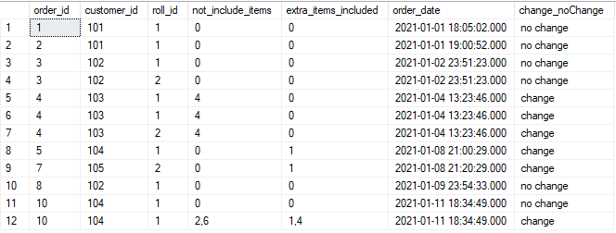

Final solution:

with temp_customer_orders (order_id,customer_id,roll_id,not_include_items,extra_items_included,order_date) as

(

select order_id,customer_id,roll_id, case when not_include_items is null or not_include_items=' ' then '0' else not_include_items

end as new_not_include_items,

case when extra_items_included is null or extra_items_included='NaN' or extra_items_included=' ' then '0' else extra_items_included

end as new_extra_items_included, order_date from customer_orders

)

, temp_driver_order(order_id,driver_id,pickup_time,distance,duration,new_cancellation) as

(

select order_id,driver_id,pickup_time,distance,duration,

case when cancellation in ('cancellation','Customer Cancellation') then 0 else 1 end as new_cancellation

from driver_order

)

select customer_id,change_nochange,count(order_id) as at_least_1_change from

(

select *, case when not_include_items = '0' and extra_items_included = '0' then 'no change' else 'change' end as change_noChange

from temp_customer_orders where order_id in (select order_id from temp_driver_order where new_cancellation !=0))a

group by customer_id,change_noChange

8. how many rolls were deliverd that had both exclusions and extras?

with temp_customer_orders (order_id,customer_id,roll_id,not_include_items,extra_items_included,order_date) as

(

select order_id,customer_id,roll_id, case when not_include_items is null or not_include_items=' ' then '0' else not_include_items

end as new_not_include_items,

case when extra_items_included is null or extra_items_included='NaN' or extra_items_included=' ' then '0' else extra_items_included

end as new_extra_items_included, order_date from customer_orders

)

, temp_driver_order(order_id,driver_id,pickup_time,distance,duration,new_cancellation) as

(

select order_id,driver_id,pickup_time,distance,duration,

case when cancellation in ('cancellation','Customer Cancellation') then 0 else 1 end as new_cancellation

from driver_order

)

select *, case when not_include_items != '0' and extra_items_included != '0' then 'both included extras' else 'either 1 included or extra'

end as change_noChange

from temp_customer_orders where order_id in (select order_id from temp_driver_order where new_cancellation !=0)

Final solution:

with temp_customer_orders (order_id,customer_id,roll_id,not_include_items,extra_items_included,order_date) as

(

select order_id,customer_id,roll_id, case when not_include_items is null or not_include_items=' ' then '0' else not_include_items

end as new_not_include_items,

case when extra_items_included is null or extra_items_included='NaN' or extra_items_included=' ' then '0' else extra_items_included

end as new_extra_items_included, order_date from customer_orders

)

, temp_driver_order(order_id,driver_id,pickup_time,distance,duration,new_cancellation) as

(

select order_id,driver_id,pickup_time,distance,duration,

case when cancellation in ('cancellation','Customer Cancellation') then 0 else 1 end as new_cancellation

from driver_order

)

select change_noChange,count(change_noChange) as cnt from

(select *, case when not_include_items != '0' and extra_items_included != '0' then 'both included extras' else 'either 1 included or extra'

end as change_noChange

from temp_customer_orders where order_id in (select order_id from temp_driver_order where new_cancellation !=0))a

group by change_noChange

9. what is the total number of rolls ordered for each hour of the day?

Step:1 select *,datepart(hour,order_date) as hr from customer_orders

Step 2:

select *,concat(cast(datepart(hour,order_date) as varchar),'-',cast(datepart(hour,order_date)+1 as varchar)) hours_bucket from customer_orders

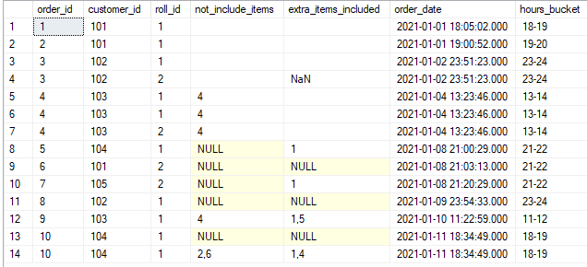

Final solution:

select hours_bucket,count(hours_bucket) as cnt from

(select *,

concat(cast(datepart(hour,order_date) as varchar),'-',cast(datepart(hour,order_date)+1 as varchar)) hours_bucket from customer_orders)a

group by hours_bucket

10. what was the number of orders for each day of the week?

Step 1:

select * ,datename(dw, order_date) dow from customer_orders

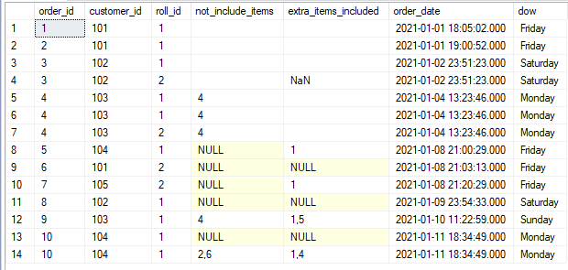

Step 2:

select dow,count(distinct order_id) cnt from

(select * ,datename(dw, order_date) dow from customer_orders)a

group by dow

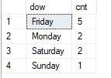

B. driver and customer experience:

1. what is the average time in minutes it took for each driver to arrive at the fasoos hq to pickup the order?

select driver_id,sum(Time_taken_in_minutes)/count(order_id) from

(select * from

(select *,row_number()over(partition by order_id order by Time_taken_in_minutes)rnk from

(select a.order_id,a.customer_id,a.roll_id,a.not_include_items,a.extra_items_included,a.order_date,

b.driver_id,b.pickup_time,b.duration,b.cancellation,datediff(minute,a.order_date,b.pickup_time) Time_taken_in_minutes

from customer_orders a inner join driver_order b on a.order_id=b.order_id

where b.pickup_time is not null)a)b where rnk=1)c

group by driver_id

2. is there any relationship between the number of rolls and how long the order takes to prepare?

select order_id,count(roll_id) as counts,sum(Time_taken_in_minutes)/count(roll_id) tyme from

(select a.order_id,a.customer_id,a.roll_id,a.not_include_items,a.extra_items_included,a.order_date,

b.driver_id,b.pickup_time,b.duration,b.cancellation,datediff(minute,a.order_date,b.pickup_time) Time_taken_in_minutes

from customer_orders a inner join driver_order b on a.order_id=b.order_id

where b.pickup_time is not null)a

group by order_id

3. what was the average distance travel for each customer?

Note: since in distance column, it consist of km so we need to replace km to do sum other wise it Is a varchar so we need to convert to flaot by using cast. And in row 8 there is a space between 23.4 and km so we use trim to remove this space

select customer_id,sum(distance)/count(order_id) as average_distance from

(select * from

(select *,row_number()over(partition by order_id order by Time_taken_in_minutes)rnk from

(select a.order_id,a.customer_id,a.roll_id,a.not_include_items,a.extra_items_included,a.order_date,

b.driver_id,b.pickup_time,

cast(trim(replace(lower(b.distance),'km','')) as decimal(4,2)) distance,

b.duration,b.cancellation,datediff(minute,a.order_date,b.pickup_time) Time_taken_in_minutes

from customer_orders a inner join driver_order b on a.order_id=b.order_id

where b.pickup_time is not null)a)b where rnk=1)c

group by customer_id

4. what is the difference between the longest and shortes delivery time for all orders?

Step 1:

select duration from driver_order where duration is not null

Here we are seeing different kind of minutes so we need to replace it using charindex

select duration,charindex('m',duration) from driver_order where duration is not null

So with the help of charindex we identify the position from where minute or min or minutes is starting the we will use left

left(duration,charindex('m',duration,-1)) else duration

this code will select all the values before ‘m’ i.e 32,27 etc and if ‘m; is not available it will return the value present in the cell.

select duration, case when duration like '%min%' then left(duration,charindex('m',duration)-1) else

duration end as duration

from driver_order where duration is not null

This is still varchar we need to convert to decimal or integer

(select cast(case when duration like '%min%' then left(duration,charindex('m',duration)-1) else

duration end as integer) as duration

from driver_order where duration is not null)

now duration column is converted to integer datatype:

final solution:

select max(duration) as max_durations,min(duration) as min_durations,(max(duration)-min(duration)) as diff from

(select cast(case when duration like '%min%' then left(duration,charindex('m',duration)-1) else

duration end as integer) as duration

from driver_order where duration is not null)f

5. what was the average speed for each driver for each delivery and do you notice any trend for these values?

Step:1

select order_id,count(roll_id) from customer_orders group by order_id

Step 2:

select a.order_id, a.driver_id,cast(a.distance/a.duration as decimal(10,3)) as speed ,b.cnt from

(select order_id, driver_id,cast(trim(replace(lower(distance),'km','')) as decimal(4,2)) distance,cast(case when duration like '%min%' then left(duration,charindex('m',duration)-1) else

duration end as integer) as duration from driver_order where distance is not null)a inner join

(select order_id,count(roll_id) as cnt from customer_orders group by order_id)b on a.order_id = b.order_id

6. what is the succesful delivery percentage for each driver?

select driver_id ,cancellation,case when lower(cancellation) like '%cancel%' then 0 else 1 end can_per from driver_order

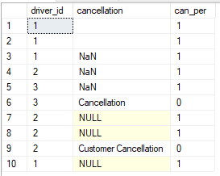

select driver_id,s,t,s/t as cancelled_percentage from

(select driver_id,sum(can_per) s, count(driver_id) t from

(select driver_id ,cancellation,case when lower(cancellation) like '%cancel%' then 0 else 1 end can_per from driver_order)a

group by driver_id)b

So it is an incorrect because there are some cancelled delivery for driver 2 but cancelled percentage is 0, it is because we are not converting it to decimal. So it is giving whole number.

select driver_id,s,t,s*1.0/t as cancelled_percentage from

(select driver_id,sum(can_per) s, count(driver_id) t from

(select driver_id ,cancellation,case when lower(cancellation) like '%cancel%' then 0 else 1 end can_per from driver_order)a

group by driver_id)b

Now converting to percentage:

Final result:

select driver_id,s,t,(s*1.0/t)*100 as cancelled_percentage from

(select driver_id,sum(can_per) s, count(driver_id) t from

(select driver_id ,cancellation,case when lower(cancellation) like '%cancel%' then 0 else 1 end can_per from driver_order)a

group by driver_id)b

